5/22/2026
Shekhar Podutwar
22/5/2026
Cloud-Based Website Hosting Using AWS EC2
Using AWS EC2 and Linux Server

Contents

Document Version History……………………………….…………………………………………….1
Introduction…………………….…………………………………………………………………………….2
Objectives…………………….………………………..….………………………………………………….3
Tools & Technologies Used…………………………………………………………………………….4
Architecture Overview ………………………………………………………………………………….5
Step-by-Step Implementation …………………………………..………………………………….6

Document Version History

Version Number | Date Modified | Author | Changes
Draft | 22/5/2026 | Shekhar | Draft Version

Introduction
This project focuses on hosting a website on an Amazon Web Services EC2 instance using a Linux server environment. The objective of the project is to deploy and manage a web application on the cloud by configuring a virtual server, installing a web server, and making the website accessible over the internet.
The EC2 instance was launched and configured with appropriate security groups and network settings. The server was accessed securely using the PuTTY tool through SSH authentication. A web server such as Apache or Nginx was installed and configured to host the website files.
The project demonstrates cloud hosting concepts including server provisioning, remote server management, web server configuration, website deployment, and public access management on AWS infrastructure.

Objectives
The main objective of this project is to deploy and host a website on AWS cloud infrastructure using an EC2 Linux server.
The project aims to:
- Launch and configure AWS EC2 instances.
- Connect securely to the server using SSH and PuTTY.
- Install and configure a web server (Apache/Nginx).
- Deploy website files to the server.
- Enable public access to the hosted website.
- Understand cloud hosting and server management concepts.
- Improve knowledge of AWS infrastructure and Linux administration.

Tools and Technologies
Tool / Technology | Purpose
Amazon Web Services (AWS EC2) | Cloud server hosting
Linux (Ubuntu/Amazon Linux/CentOS) | Operating system
PuTTY | Remote SSH connection
Apache / Nginx | Web server hosting
HTML / CSS / JavaScript | Website frontend development
SSH | Secure remote access
Security Groups | Firewall and port management
Public IP / Elastic IP | Internet accessibility

Architecture Overview
User Browser
│
▼
Public IP / Domain
│
▼
AWS EC2 Instance
(Linux Server)
│
▼
Apache / Nginx Web Server
│
▼
Hosted Website Files
(HTML, CSS, JS)
Step-by-Step Implementation

Step1: Create an EC2 Instance
- Go to Amazon Web Services console
- Open EC2 Dashboard • Click Launch Instance
- Choose:
  - AMI: Amazon Linux (or Amazon Linux 2) o Instance type: t2.micro (free tier) • Create / select Key Pair (.pem file) • In Security Group:
  - Allow:
    - SSH (Port 22)
    - HTTP (Port 80) (important)

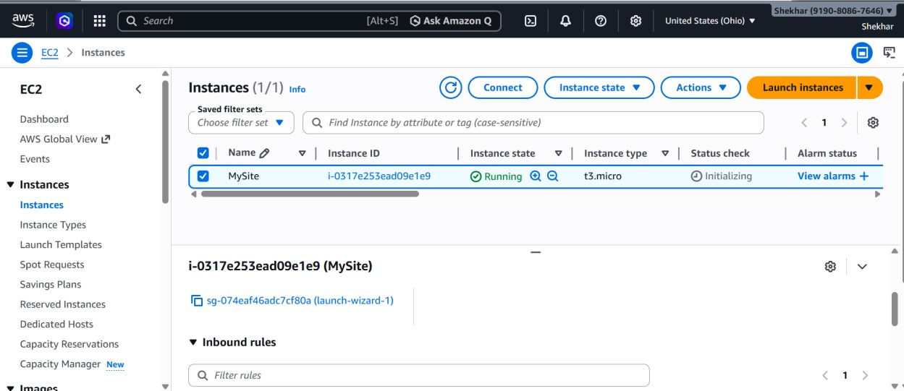

Step2: Connect to Instance (PuTTY)
- Convert .ppk using PuTTYgen
- Open PuTTY
- Connect
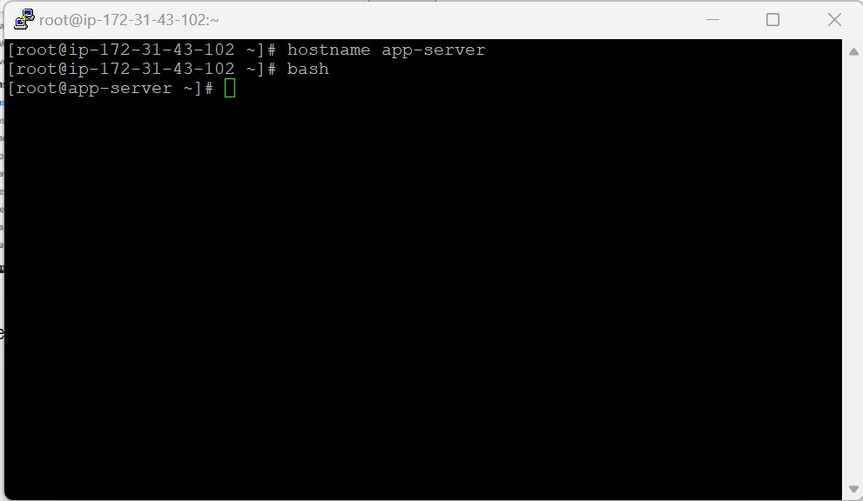

Step3: Install Apache Web Server
- Yum install –y httpd
- Systemctl start httpd
- Echo “HI shekhar Great job” > /var/www/html/.index.html
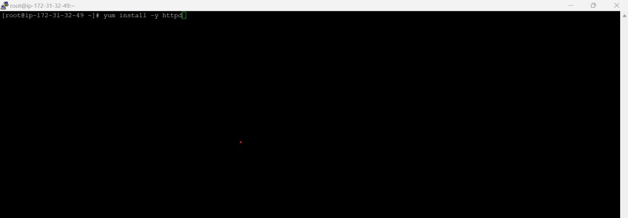

Step4: Open Port 80 (If Not Already)
• Go to EC2 → Security Groups • Edit inbound rules:
- Type: HTTP o Port: 80
- Source: Anywhere (ipv4)

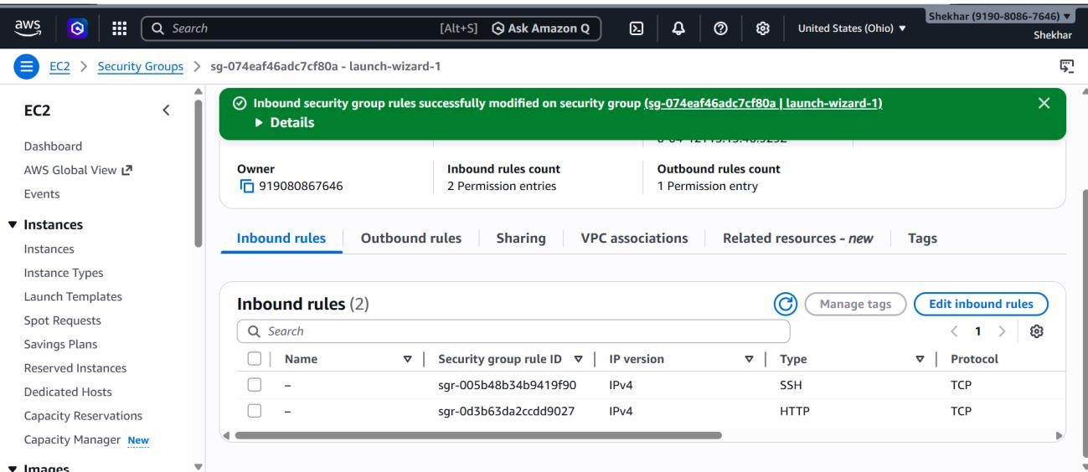

Step5: Create Web Page
Index.html Save: :wq!

Step6: Edit Using Vim (Optional)
Vim /var/www/html/index.html
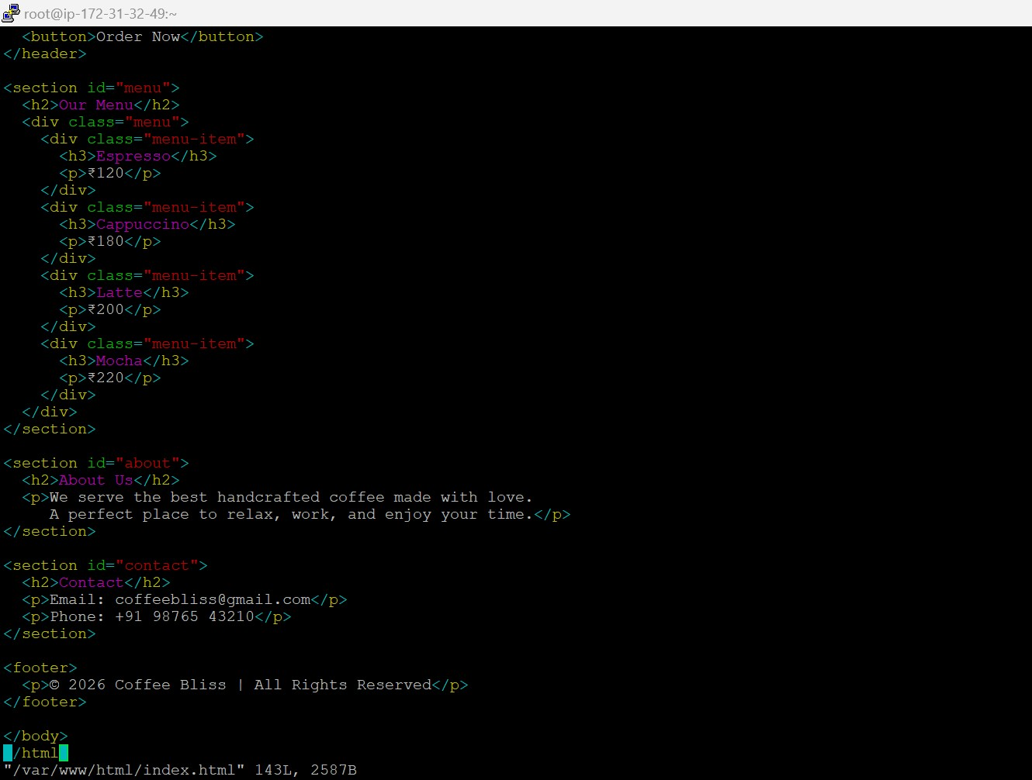

Step7: Access Website
- Copy Public IP of EC2
- Paste in browser:
- Public ip

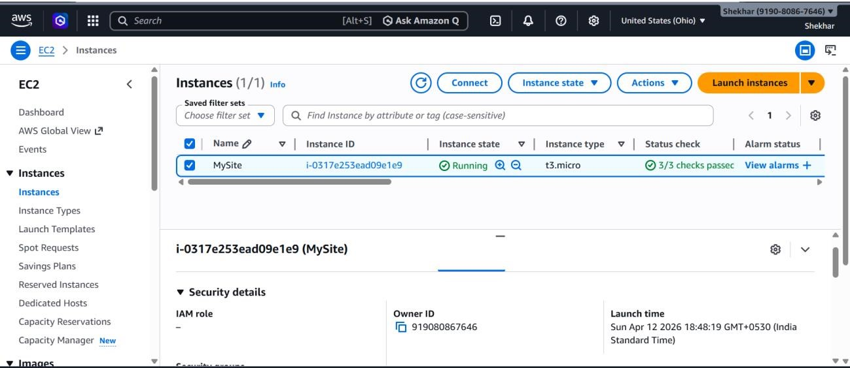

Step8: You should see your webpage
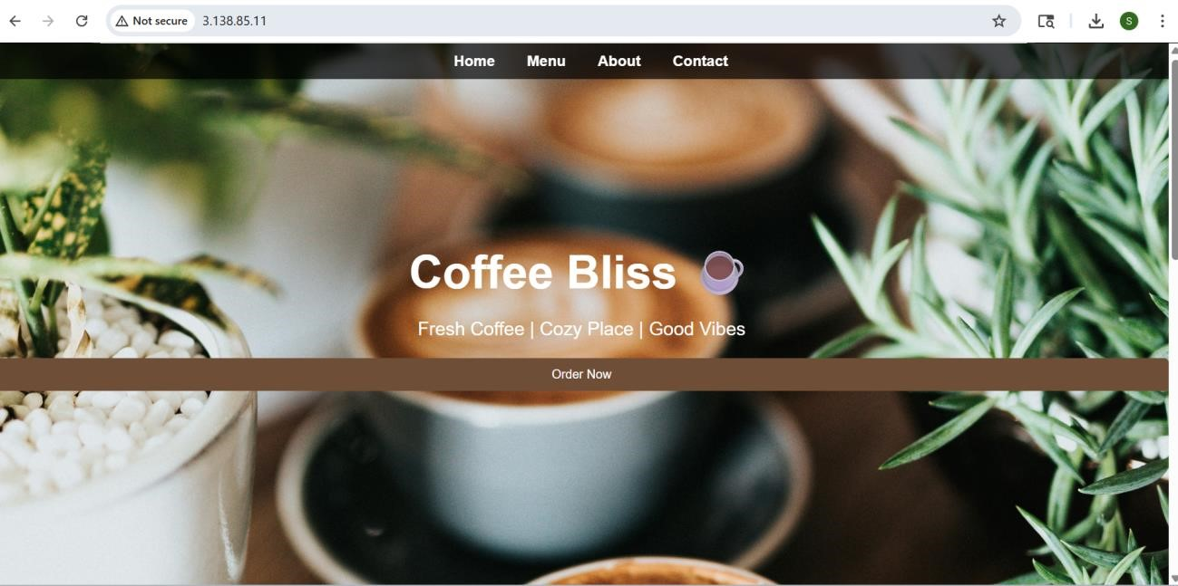

Conclusion
Hosting a website on AWS EC2 provides a scalable, flexible, and cost-effective cloud hosting solution. By configuring a Linux server, installing a web server, and deploying website files, the project demonstrates practical knowledge of cloud infrastructure, Linux administration, web hosting, and AWS services. This implementation helps in understanding real-world DevOps and cloud deployment practices.

